EXPERIMENT 6C

DATA VISUALIZATION USING POWER BI – Stroke Dataset

Aim
To import, transform, analyze, and visualize data using Power BI Desktop and create interactive dashboards and reports for decision-making.

Algorithm 1

Step 1: Open Power BI Desktop.
Step 2: Select: Home → Get Data → Text/CSV
Step 3: Browse and select the healthcare-dataset-stroke-data.csv dataset.
Step 4: Preview the dataset.
Step 5: Click Load to import the dataset.
Step 6: Verify the imported data in Power BI.

Dataset Used
The dataset contains patient-related healthcare information such as:
- Patient ID
- Age
- Gender
- Hypertension
- Heart Disease
- Ever Married
- Work Type
- Residence Type

- Average Glucose Level
- BMI
- Smoking Status
- Stroke

Output
The healthcare stroke dataset was successfully imported into Power BI.

ALGORITHM 2 — DATA TRANSFORMATION USING POWER QUERY
Step 1: Select Home → Transform Data.
Step 2: Power Query Editor is opened.
Step 3: Remove duplicate records.
Step 4: Handle missing/null values.
For the BMI column:
- N/A values were converted to null.
- The median BMI was calculated.
- Median BMI obtained = 28.1
- The missing BMI values were replaced with 28.1.
Step 5: Ensure appropriate data types.
- BMI → Decimal Number
- Age → Decimal Number
Step 6: Rename columns for better readability.
Step 7: Select Close & Apply to load the cleaned data into Power BI.

Output
The healthcare dataset was cleaned, transformed and successfully loaded into Power BI.\

ALGORITHM 3 — CREATING A BAR CHART

Objective
To visualize the distribution of patients based on gender.
Step 1: Select the Clustered Bar Chart visualization.
Step 2: Drag:
Gender → Y-axis / Axis
Step 3: Drag:
Patient ID → X-axis / Values
Power BI uses Count of Patient ID to represent the number of patients.
Step 4: Format the chart and provide the title: Patient Distribution by Gender

Output Visualization
A bar chart displaying the number of patients belonging to each gender category.
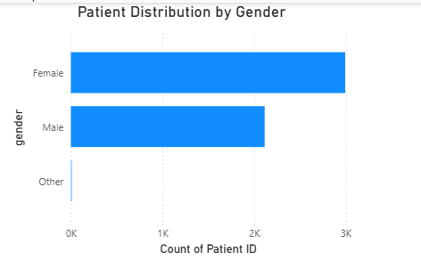

Interpretation
The bar chart allows comparison of the number of patients across Female, Male and Other categories.

ALGORITHM 4 — CREATING A PIE CHART

Objective
To visualize the distribution of patients according to stroke occurrence.
Step 1: Select the Pie Chart visualization.
Step 2: Drag:
Stroke → Legend
Step 3: Drag:
Patient ID → Values
Ensure it is aggregated as Count of Patient ID.
Step 4: Enable Data Labels.
Step 5: Give the chart the title: Stroke Distribution

Output Visualization
A pie chart showing the proportion of patients who experienced a stroke and those who did not.
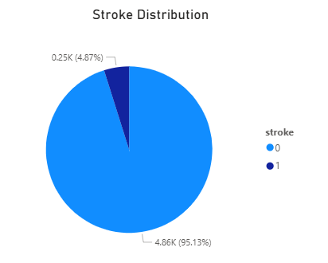

Interpretation
- 0 → No stroke
- 1 → Stroke
The pie chart provides a visual representation of the proportion of stroke and non-stroke cases.

ALGORITHM 5 — CREATING A KPI CARD

Objective
To display the total number of patients as a key performance indicator.
Step 1: Select the Card visualization.
Step 2: Create a DAX measure:
Total Patients =
COUNT('healthcare-dataset-stroke-data'[Patient ID])
Step 3: Drag Total Patients into the Card.
Step 4: Apply suitable formatting.
Step 5: Set the title: Total Patients

Output
The Card displays the total number of patients in the dataset.
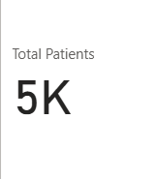

ALGORITHM 6 — CREATING A SLICER

Objective
To provide interactive filtering of the healthcare dashboard based on gender.
Step 1: Select the Slicer visualization.
Step 2: Drag: Gender → Slicer Field
Step 3: The slicer displays the available gender categories:
- Female
- Male
- Other
Step 4: Enable Single Selection if required.
Step 5: Apply the slicer to the dashboard.

Output
An interactive Gender slicer is created.
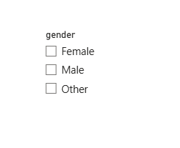

Dashboard Behavior
When a gender is selected, the other visualizations on the dashboard are automatically filtered according to the selected gender.

ALGORITHM 7 — CREATING DAX CALCULATIONS

Objective
To calculate statistical measures from the healthcare dataset using DAX.

1. Average Age
Average Age =
AVERAGE('healthcare-dataset-stroke-data'[age])

2. Maximum Age
Maximum Age =
MAX('healthcare-dataset-stroke-data'[age])

3. Minimum Age
Minimum Age =
MIN('healthcare-dataset-stroke-data'[age])

Output
The following DAX measures are created:
- Average Age
- Maximum Age
- Minimum Age
These measures can be displayed using Card visualizations.
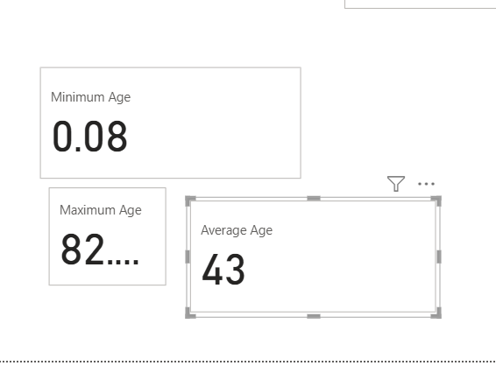

ALGORITHM 8 — CREATING DASHBOARD

Objective
To combine the created visualizations into an interactive healthcare dashboard.
Step 1: Add the Total Patients KPI Card.
Step 2: Add the Average Age Card.
Step 3: Add the Maximum Age Card.
Step 4: Add the Minimum Age Card.
Step 5: Add the Patient Distribution by Gender Bar Chart.
Step 6: Add the Stroke Distribution Pie Chart.
Step 7: Add the Gender Slicer.
Step 8: Arrange the visualizations neatly on a single report page.

Output
An interactive Healthcare Patient Analytics Dashboard was created successfully using Power BI.
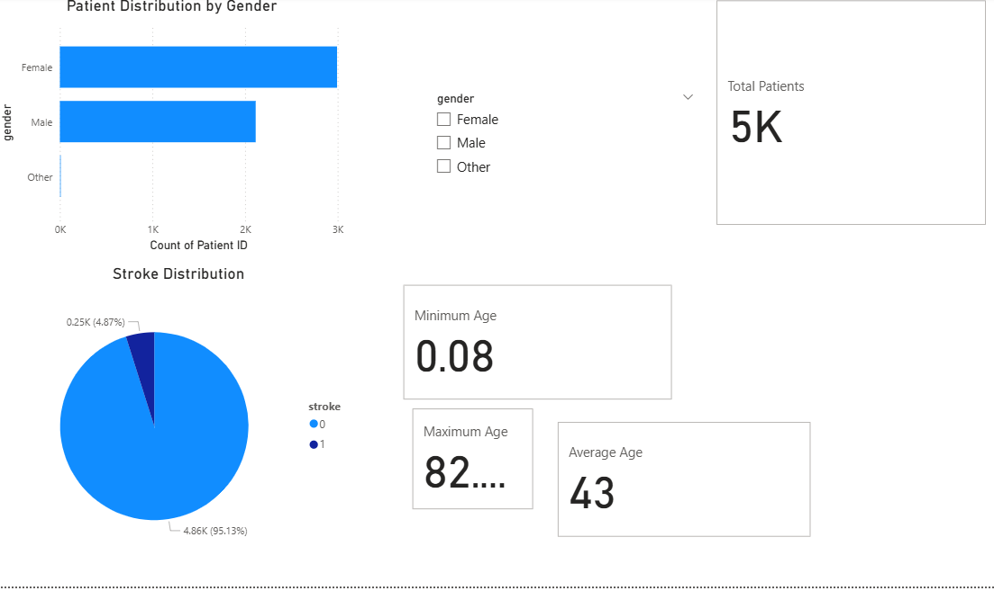

RESULT:
Thus, the healthcare stroke dataset was successfully imported, cleaned, transformed, analyzed and visualized using Power BI. An interactive dashboard was created using bar charts, pie charts, KPI cards, DAX measures and slicers to effectively analyze patient demographics and stroke distribution.

